INTRO 🤝
Imagine you are a Data Scientist at an Iowa-based real estate investment firm. The firm makes money by spotting underpriced homes: ones they can buy below market, then hold or resell at a profit.

Your manager wants a model that predicts what a house should sell for based on its features (bedrooms, lot size, year built, etc.). If the model says a home should go for $750K and it's listed at $620K, that's a deal worth digging into.

You don't have access to your firm's proprietary data yet, so you're going to sharpen your technique on a public dataset hosted by Kaggle, a platform where data scientists share competitions and code. The dataset contains 1,460 home sales with the final price plus 79 features describing each property [link].

By the end of this project you'll have built, tested, and presented a real predictive model in Python.

TASK OUTLINE 📓
Fundamentally data science and analytics is all about understanding and utilizing available data to guide decision making. On the internet today there is almost unlimited data and resources to learn techniques to unlock insights from that data.

One platform that hosts data science competitions is Kaggle; in this project we will explore a dataset around housing prices and walk through some data science techniques using their platform and python code.

This project assumes no prior experience with python or Kaggle. If you are familiar with either you can quickly move through the basics and dig in further to explore more advanced code written by others and shared on Kaggle.

- PART 1: Kaggle Account & Notebook
  - Create a Kaggle Account & Notebook
  - Load Datasets
- PART 2: EDA (Exploratory Data Analysis)
  - Review Data Assumptions
  - Plot the Distribution of Sale Prices
  - [OPTIONAL] Explore a Non-Numeric Variable
- PART 3: Model Creation
  - Select Features to Use
  - Run a Decision Tree Model
- PART 4: Model Validation
  - Evaluate with Mean Absolute Error
  - [OPTIONAL] Beat Your Model
- PART 5: Present Findings to Leadership

HOW TO COMPLETE TASK ⚡

PART 1: Kaggle Account & Notebook

Step 1: Create a Kaggle Account & Notebook
Let’s start by navigating to the dataset on kaggle. Once you are there, register for a Kaggle account (or sign in) using the button at the top right.

After you are signed in, take a moment to browse the description and data tabs to start to get a sense of the available data. Don’t worry if everything doesn’t make sense, there is a ton of information here and we will step through everything together! As a data scientist it is important to not get overwhelmed with the volume of information: it is your job to filter out what is truly significant.

When you are ready, navigate to the code tab and click on New Notebook.
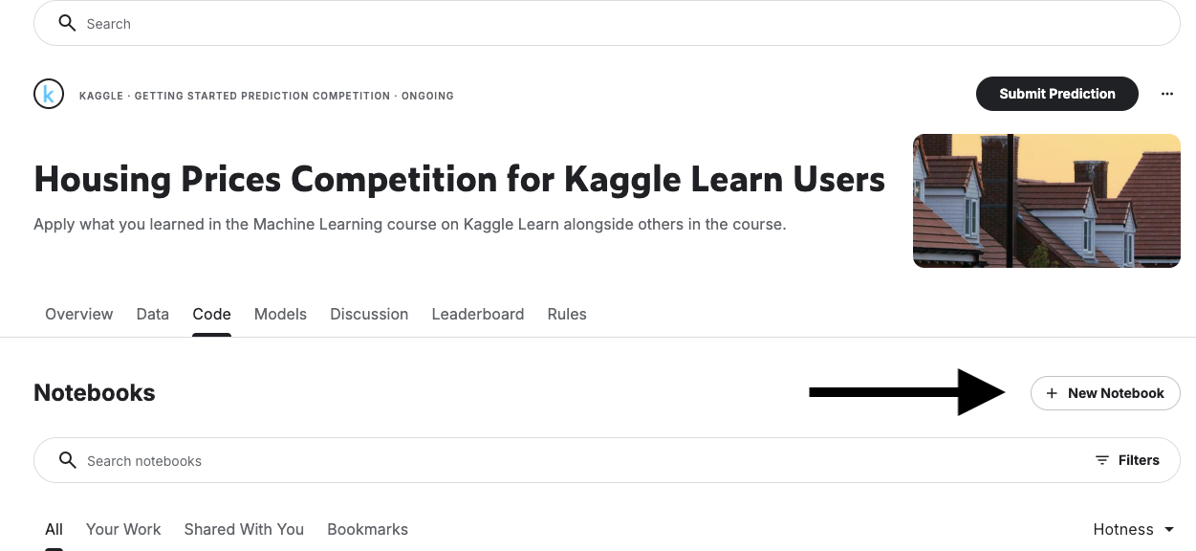

Give it a moment and you will see a screen with some python code that looks like this:

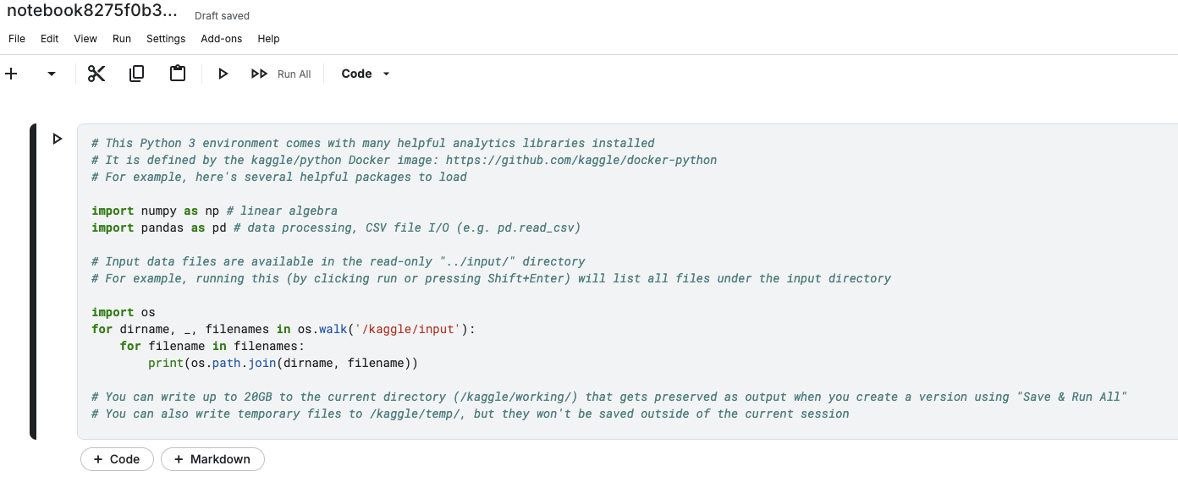

First let’s name your notebook

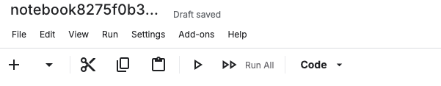

And rename it to [YOUR NAME] - Possible Data Science Project

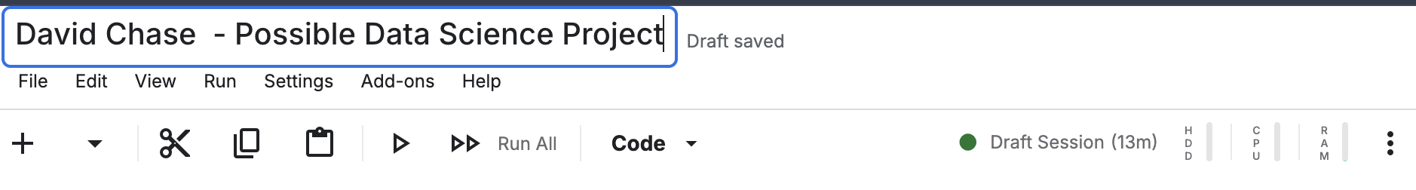

You are now in a Jupyter notebook. It's organized into cells, and there are two kinds:
- Code cells contain Python code you can run. When you run a code cell, its output appears just below it.
- Markdown cells contain plain text: notes, headings, explanations. Markdown is just a simple way to format text.

Use the legend below to find each element on your screen.
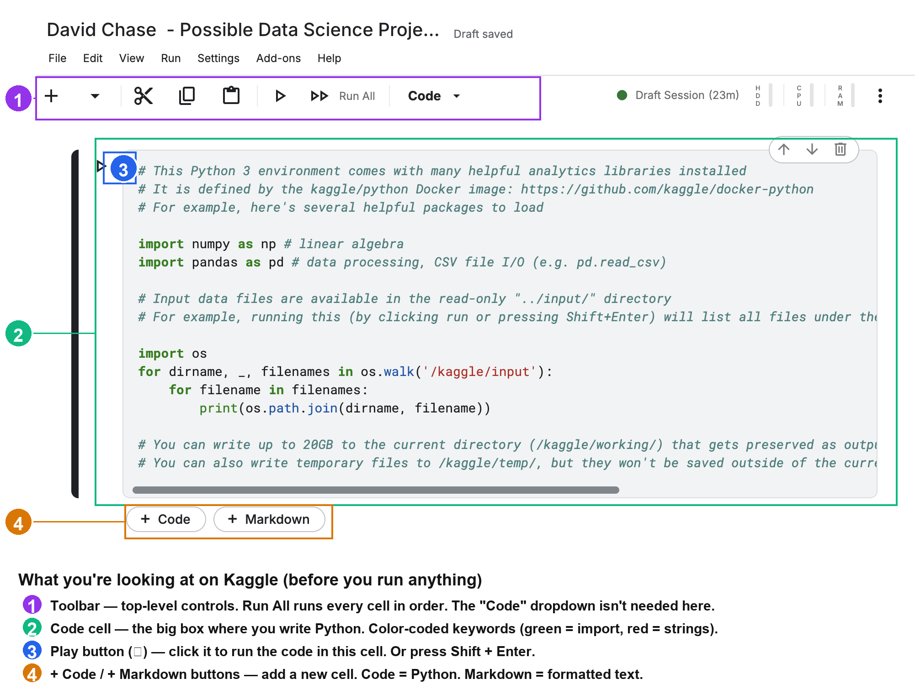

OK, let’s run some code :)

Step 2: Load Data
Click into the code cell, then hit the play button (▶) to run the code. The first time you start running code it will take a minute as the session gets started up. On the top-right corner is the session indicator that will tell you when it is ready. You will see the output from the code once it runs, give it a minute 😀.

Note: You can also run a code block by clicking SHIFT+ENTER while inside of it.

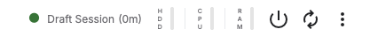
Once the code runs you will see a list of file paths which have been loaded:

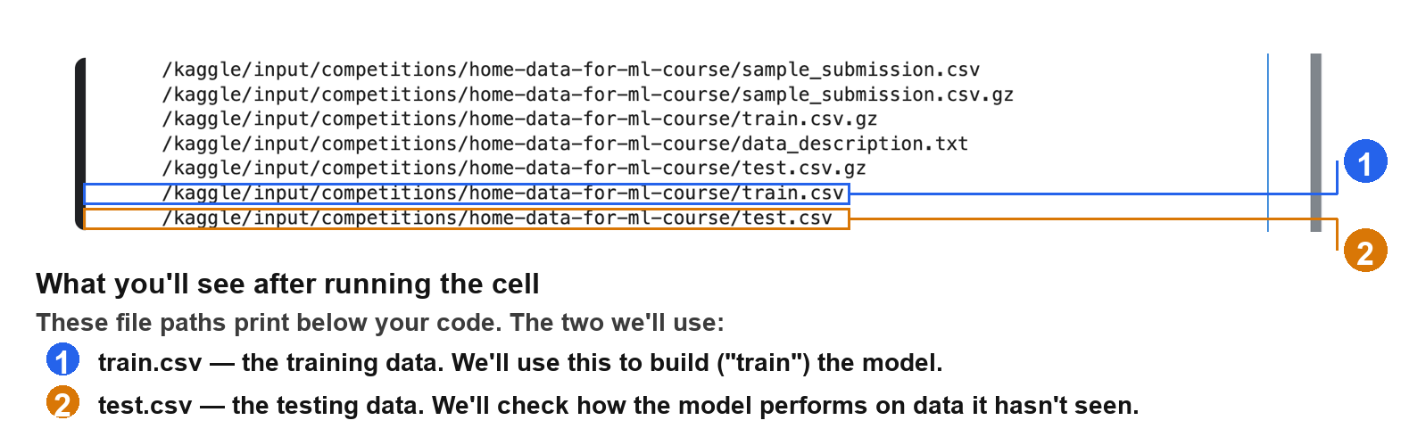
The two we care about are train.csv and test.csv. Now let's load both into pandas so we can start working with them using Python.

When doing machine learning projects it's typical to separate data into two parts: the training data for building a model, and the testing data for validating its results.

Pandas (which we imported as pd) has a read_csv function that does the loading, and we'll check .shape to see how many rows and columns each one has. Create a new code block and type in the following code:

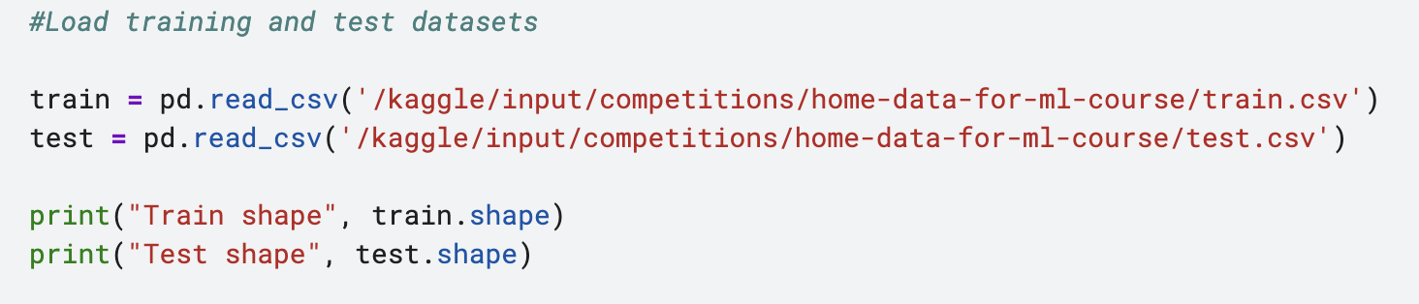

What is the resulting output after hitting the play button or pushing CTRL-ENTER? | Train shape (1460, 81)  Test shape (1459, 80)

So what happened? Two things:
- We called read_csv, which loaded each file into a DataFrame. A CSV is just text sitting in a file; a DataFrame is that same data as a table Python can work with: sort, filter, run math, feed into a model. Think of the CSV as a file on your desktop and the DataFrame as that file opened in Excel.
- We called .shape, which told us each dataset's size as (rows, columns). Each row is one house sale, and each column is a piece of information about that house. The training set has one more column than the test set, and that column is SalePrice. It's left out of the test set on purpose: you learn the pattern from houses where you know the price, then predict it for houses where you don't. That's the core idea of machine learning.

Before we move on, one quick question:
A CSV file and a DataFrame both hold table-like data. What's the difference and why did we need to convert from one to the other? | CSV is a more a plaintext file extension which uses commas to allow for easy storage while Dataframe is more a data manipulation file extension allowing it to be used in data analysis like in pandas

Now the data is loaded and we are done with Part 1!

PART 2: EDA (Exploratory Data Analysis)

Step 1: Review Data Assumptions
In Part 1 you saw the training set has 81 columns. Now let's understand what those columns actually are, and whether we can trust this data for the job.

One of the most important parts of data science is really understanding what your dataset contains, and some of that starts before you even look at the numbers. Where did the data come from? Is it applicable to our use case? Every data professional asks these before diving into modeling, and fortunately Kaggle hands us the answers.

Go back to the competition page and keep this page up throughout. Read through the Overview (start with the Competition Description) and the Data tab.

What City/State is the data from? | Ames, Iowa
How many variables are there in the dataset? | 79 explanatory variables to help in predicting the house prices
What are some assumptions that we will make by using this data for modeling house sale prices? | That past data on house prices is representative on future data and can be used in predicting said future date  The data picked is representative of the housing market in Ames, Iowa

Step 2: Plot the Distribution of Sale Prices
Thinking critically, since we want to model the sale price, we need to know what prices the houses have sold for in the data set! We can visualize this with a histogram and look at the variable SalePrice. Pandas has a built-in plotting function (plot) which we can utilize to make a chart.

First we need to select the data we want to look at: SalePrice. We pull this out from the train data by using dot-notation. Since we are going to use this as the predicted value, we can store this as a variable y. We will use this later in our model, typically the variable being predicted is labeled as y.

Create a new code block to set up this variable and then plot the histogram using the plot function.
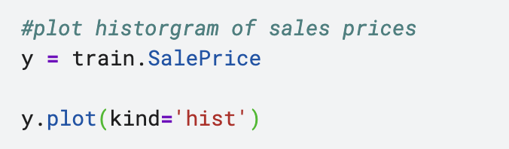

Paste a screenshot of the resulting histogram into this document below: | 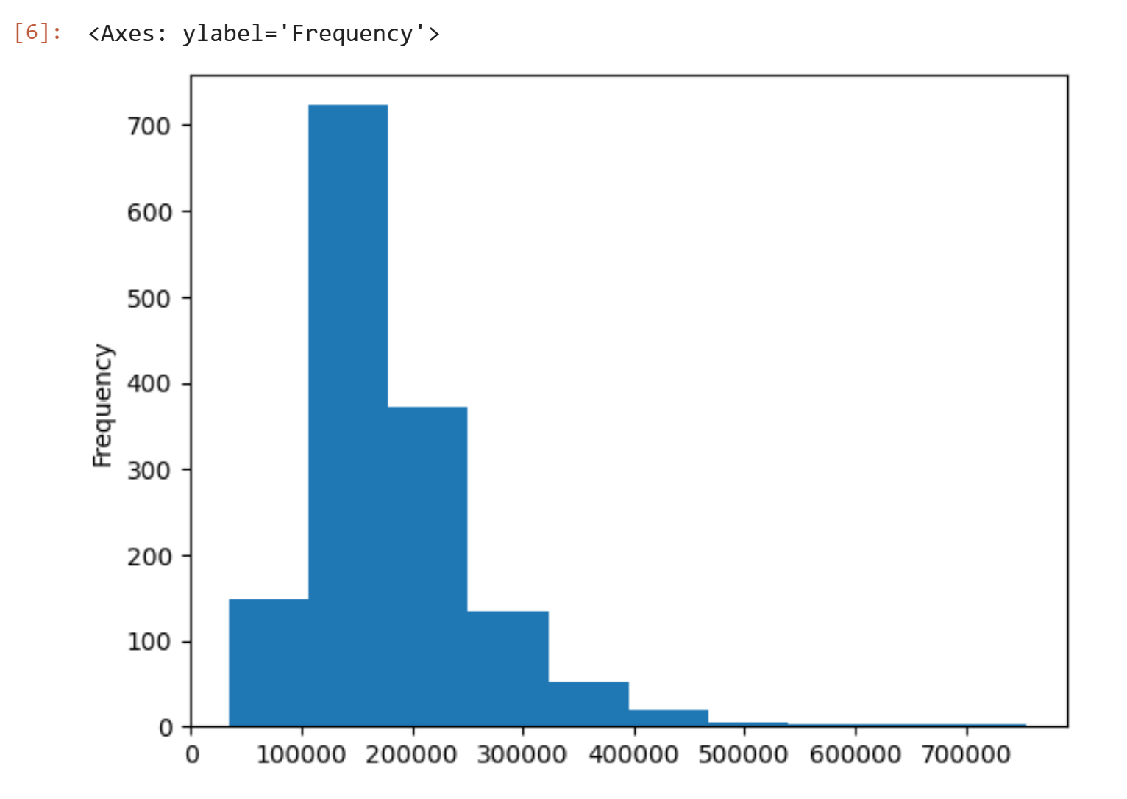

Now let's get the actual numbers behind that shape. Run describe() on the same variable: y.describe()

Based on the above histogram and the describe data, answer the following questions:

Should we use this model to predict the price for $1M+ homes? | Probably not since all of our data points are below the price of $1M

Now let's explore on your own. You've seen the recipe - to look at any numeric column, just swap its name into the same two lines:

train.ColumnName.plot(kind='hist')
train.ColumnName.describe()

To find a numeric column, open the Data tab, click train.csv, and look at the symbol next to each column name: # means it's a number (good for a histogram), A means it's text. Pick any column with a #

NOTE: If you get an error with your histogram, you are probably trying to plot a non-numeric variable (eg. MSZoning). See the Optional step 3 below.

Pick another numerical variable that interests you and write the code to plot its histogram and run describe() on it.  Write the code here: | Year built  y = train.YearBuilt  y.plot(kind = 'hist')  y.describe  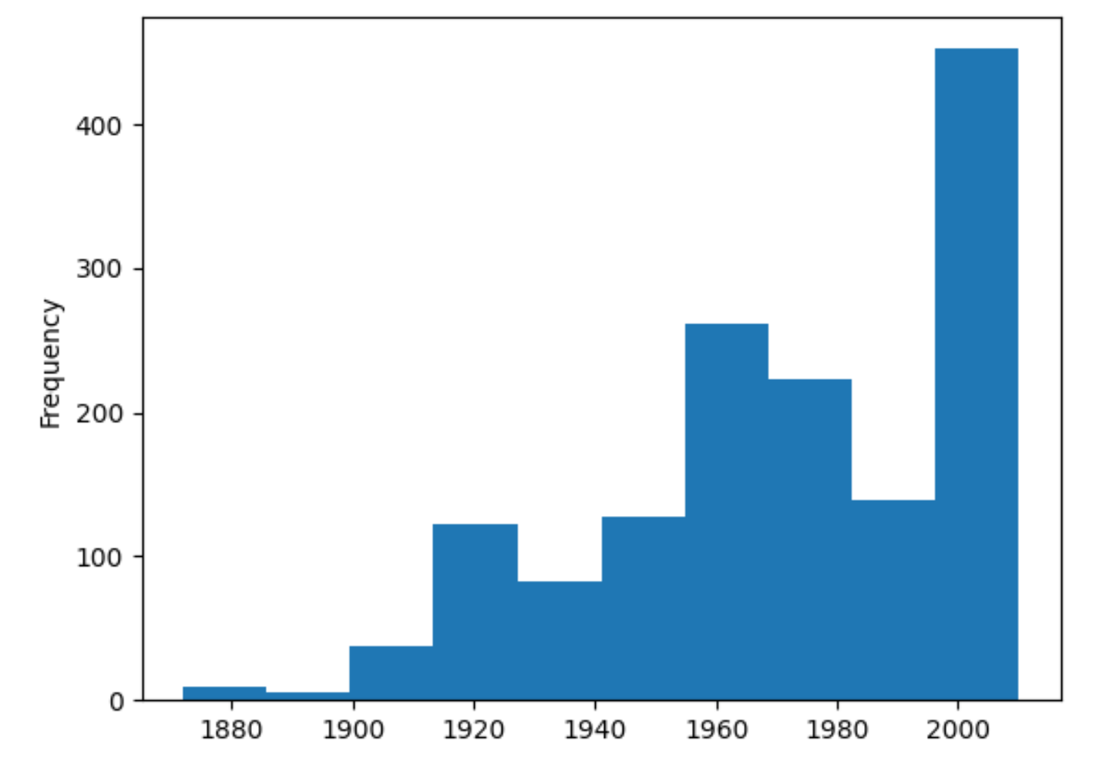
Any interesting findings? | In the training dataset, there were more houses built in the 2000s than in previous years, almost double than in 1980s

[OPTIONAL] Step 3: Explore a Non-Numeric Variable
So far you've only looked at numeric columns (the ones with a # in the Data tab). But histograms only work on numbers. For text columns (like Neighborhood), you count the categories instead. That's one new function: value_counts().

Start with a text column like Neighborhood. First run describe() on it. Use the formulas we have been teaching you above.

For a text column, use value_counts() instead, and plot a bar chart instead of a histogram: train.Neighborhood.value_counts().plot(kind='bar'). If you aren’t sure about the shorthand of the data returned, it can be found in data_description.txt.

This counts how many homes are in each neighborhood and charts it. What's the most common one? | North Ames

PART 3: Model Creation

Step 1: Select Features to Use
Ok let’s have some fun and build a model! Every model needs two main parts:
- Prediction Target - typically called y, SalePrice in our case
- Features - typically called X, these are the columns which we will input to our model to make the prediction.
We already created the prediction target variable y in Part 2, so now we just need to create our set of features, X.
Part of the science is knowing which columns to choose, sometimes this could be all of the columns, or sometimes things might work better with a smaller subset. For now we will start by choosing 5 numerical columns for our first model:
- GrLivArea
- YearBuilt
- BedroomAbvGr
- FullBath
- LotArea
To do this in code, we put those column names in a list (inside square brackets), then pull just those columns out of train into X. Finally we call head() to show the first 5 rows and check it worked.
Try it yourself first (optional): Before you peek at the code below, see if you can write it on your own. Stuck? Google it or ask an LLM and then check your version against ours.

(Optional) Write the code here before peaking below: | X = train[["GrLivArea","YearBuilt","BedroomAbvGr","FullBath","LotArea"]]  X.head()
Now we will share our code and you can add it to a new code block on kaggle. We added a call to the head() function to display the first 5 rows of data to verify our result.
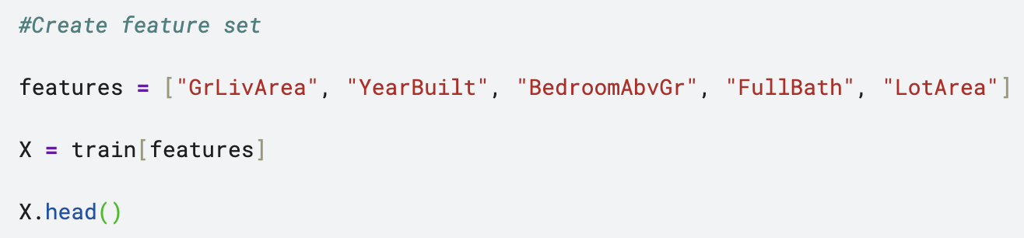

Paste your screenshot of the X.head() result. | 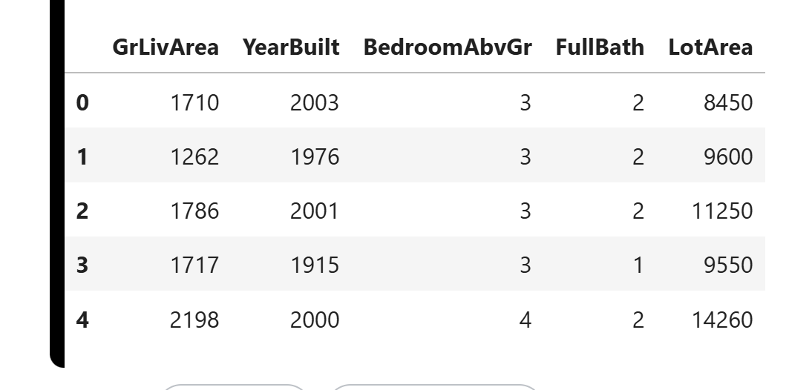
These 5 columns aren't the only things that affect price. Looking at the data, what's one other feature you'd add to the model, and why?  Note: If you choose a non-numeric feature, look up and share what you would need to do to use it in the model. | The overall quality of the finish of the house, because houses that have a better finish will attract a higher price from vendors and buyers understand that they will have to be willing to pay more for a house with a better finish

Step 2: Run a Decision Tree Model
Now we'll build the model. Every model works in two steps:
- Train it: the model studies your data and learns the patterns. (The code word for this is "fit.")
- Use it: the model predicts prices for homes using what it learned. (The code word is "predict.")
Let's start by training. We'll use a Decision Tree from scikit-learn. The nice thing about modern tools is you can build a real model in just a few lines, without knowing all the math behind it. (Curious how decision trees work? You can quickly google or ask AI about decision trees, or for a more in-depth explanation check out this article).
Remembering that we have previously set up the prediction target y and the features X, we can generate the model with only a few lines of code. Create a new code block and enter in the following code:
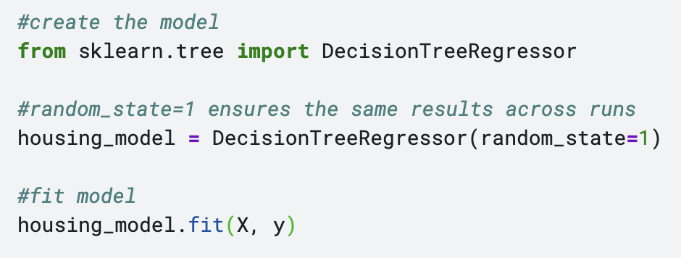Here are the explanations for each line of code (without the comments)
- from sklearn.tree import DecisionTreeRegressor
  - This brings in the Decision Tree model from the existing scikit-learn library and allows us to utilize the existing modeling algorithm
- housing_model = DecisionTreeRegressor(random_state=1)
  - This sets up the Decision Tree model. Yes, just one line of code. random_state=1 makes your results repeatable. It locks in the "random" steps so you get the exact same model and predictions every time you run, which means your numbers will match the example.
- housing_model.fit(X, y)
  - The training step. This “fits” the Decision Tree to our data. The model looks at your features (X) and the actual prices (y) and learns the patterns connecting them. Again just one line of code with a lot happening behind the scenes.
OK. So apparently we have a model now - let’s test and make sure it actually did something. Let’s run some predictions on the same train data to test that our model was created and can output data.
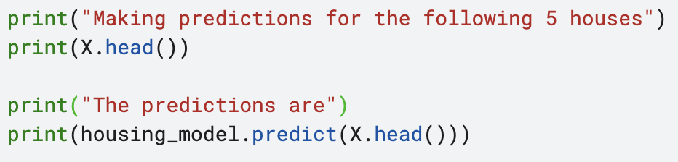
Create a new code block with the code above and then paste a screenshot of the result in line below.

Paste your screenshot of the result in this document below: | 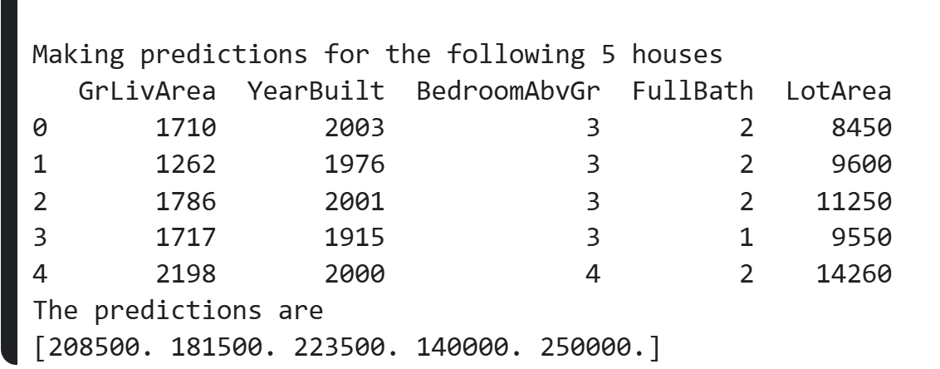
Quick check #1: When we train (fit) the model, we give it the actual prices. When we use it (predict), we don't. Why? | Because the actual prices are what we are trying to predict and see if the decision tree/ml model actually learned patterns to be able to predict the price
Quick Check #2: What do these numbers represent, and what did the model use to come up with them? | They represent predictions of the following 5 houses using their 5 features as learned patterns. Based on how decision trees work, during the training phase, it split the data into leaf nodes based on the features they had and compared their answers and then used those patterns and learn ideas to then make predictions.

PART 4: Model Validation

Step 1: Evaluate with Mean Absolute Error
Alright, we have a model - now let’s see how well it performs!

There are many metrics which can be used to evaluate the quality of a model, for now let’s start with the Mean Absolute Error (MAE). There are 3 words in that metric, we can break it down backwards starting with the error.
- Error = Actual - Predicted
  - This tells us the difference between our model and the actual value (using train/test data).
- Absolute: Take the absolute value
  - This ensures that we have a positive number even if our predicted is lower than our actual - if we did not do this positive and negative errors could offset each other when calculating the average.
- Mean: Take the average value (mean)
  - Get the average absolute error after calculating it for each individual house in the dataset. This tells us overall how far off we are from the actual.

scikit-learn has MAE built in. Let's run it on our training data. Create a new code block:

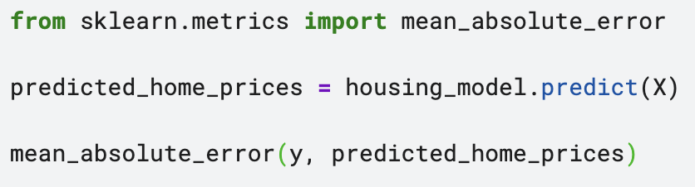

What is the MAE for the train dataset? What does this mean in layman terms and do you think our model is good? | 73.31324200913242  This means that the model was off by around 73 dollars on average in terms of estimating the sales price

That number is surprisingly small on sales that are in the hundreds of thousands. But here's the catch: we just tested the model on the exact same data we trained it on. Of course it does well, it has already seen every one of these homes.

The real question is: how does it do on homes it hasn't seen? To find out, data scientists split their data: train the model on one chunk, then test it on a separate chunk the model never saw. On Kaggle they typically provide a separate test data set which is used for their competition submissions - in this case the test file does not have the SalePrice. And, as you might have guessed, scikit-learn has a feature that allows us to do this easily 🙂

Let’s try splitting the train data into two sets - we can then rerun the model and evaluate it on new data:

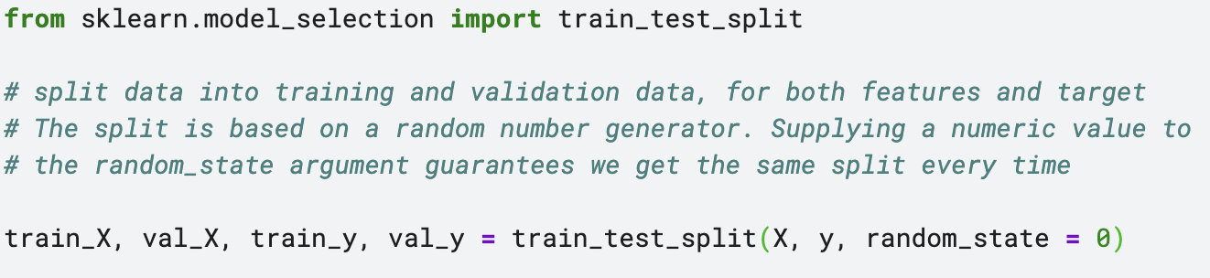
Here is a description of what the code is doing:

- from sklearn.model_selection import train_test_split
  - Brings in the feature for splitting a dataset for model training
- train_X, val_X, train_y, val_y = train_test_split(X, y, random_state = 0)
  - Creates two datasets from one:
    - train_X and train_y – These are the variables for training the model
    - val_X and val_y – These are the variables for validating the model
  - Specifying the random_state = 0 ensures the same results each time you run
Now it is time to actually write the code yourself! We will help you try to do this without an LLM to see if you get the concept, especially since you've already done all three of these. Now we just put them together on the split data:
- Train the model on train_X and train_y (hint: look back at Part 3, Step 2).
- Predict on val_X (the held back data, not train_X).
- Calculate the MAE between val_y and your predictions (step above)

Share your code here: | from sklearn.model_selection import train_test_split  train_X, val_X, train_y, val_y = train_test_split(X,y, random_state = 0)  housing_model.fit(train_X, train_y)  predicted_y = housing_model.predict(val_X)  mean_absolute_error(val_y, predicted_y)
What is the MAE for the validation dataset? | 32240.312328767122
What do you think about our model now? | It is more realistic in terms of predicting house prices as it is off by around 30,000 on average

🎉 🎉 🎉CONGRATULATIONS 🎉 🎉 🎉
You have now successfully built and tested a prediction model using Python!

If you have past experience, found this fun, or just want to explore more please feel free to continue with the optional task below. Otherwise skip to part 5.

[BONUS, OPTIONAL] Step 2: Beat Your Model
You've got a working model and, more importantly, a way to measure it (your validation MAE). So here's the real question: can you make it better?

Lowering that MAE is the goal. One of the best things about Kaggle is that expert data scientists compete on this exact dataset and share their code so others can learn. The Kaggle code page is a goldmine for seeing how they approached it and learning.

A few ideas to try beating your MAE:
- Better features: Can you add more numeric columns to your features list and re-run? Does the MAE drop? Or do you actually need all of them? Could any be combined, or do some tell you the same thing?
- How would you bring in a text column like Neighborhood? (Look up "one-hot encoding.")
- Could you try a better model by swapping the Decision Tree for a Random Forest, it's almost the same code (ask ChatGPT how), then compare the MAE.
- Explore what else is out there? Look into Linear Regression, Gradient Boosting, or XGBoost.

Your challenge: Pick at least one idea above, try it, and share three things:

What did you change? Paste your code. | I added Overall Quality in terms of house finish  features = ["GrLivArea","YearBuilt","OverallQual","BedroomAbvGr","FullBath","LotArea"]  X = train[features]  X.head()
What is your NEW MAE for the validation dataset? | 27017.21095890411
Did it beat your original MAE? Why do you think it did or didn't? | Yes. The overall quality of the house’s finish will determine how much resources that is spent on painting the housing and getting it ready to be presentable, thus driving up the cost of the house

Note: If you are feeling confident with your python/coding you can also try submitting your results to the leaderboard, try it out! Totally optional, but can be something that you share on LinkedIn and your resume.

PART 5: Present Findings to Leadership (Everyone)
With ChatGPT and other LLMs that can help even non-data folks to input correct formulas, a data scientist’s job has changed. Now, it is even more critical for analysts to be able to understand how to analyze and communicate findings.
Normally, you would do this with a Powerpoint or Google slides presentation to the core stakeholders. However, rather than have you build the actual slides, we are going to ask you to map them out below.
Originally, we had a goal to create a model that would allow us to predict housing prices based on their features. Let’s pretend you are working with a housing investment group in the Iowa area and they are looking to identify houses that might be underpriced so that they can buy them and turn a profit. They want to use your model towards that goal. Does our model accomplish that goal? Do we need to do further iterations or need anything additional?
We would like you to share what you have found and also what you might still need to explore to get a better result. This is a simple best practice on how you might communicate data results with your broader team. Both parties only have a little context on how you did the analysis, so you should be helping them understand why you did what you did.
Slide 1: Agenda  Having a concise agenda on what you are going to present is very underrated. And this step should be pretty easy since we have mapped it out for you and can be a simple numbered list :) | - Problem definition  - Methodology  - Results  - Recommendations
Slide 2: Problem Definition  This is where you contextualize the problem that we are solving for and why it is a problem. Specificity is critical here and a simple, clear problem statement should suffice. | Housing investors in Ames, Iowa struggle to find houses which are priced below their true market value. To address this, our predictive model helps to estimate a home's expected sale price based on its characteristics. By comparing the model's predicted price with the actual sale price, investors can identify potentially undervalued properties and make more informed investment decisions to maximize profit.
Slide 3: Methodology  This is how we went from Point A (Problem) to Point B (Solution).  We started at the problem. What did we pull in and do to get to the solution?  - What's your data set and what does that contain?  - What formulas did you use?  - What were we trying to solve? | - Data on sales price of houses in Ames, Iowa and contains 6 feature variables:  - GrLivArea: Above grade (ground) living area square feet  - YearBuilt: original construction date  - OverallQual: Overall material and finish quality  - BedroomAbvGr: Bedroom above grade level  - FullBath: Full bathrooms above grade  - LotArea: Lot size in square feet  - I used a Decision Tree algorithm  - We are trying to build a model that estimates fair market value of homes so investors can identify properties listed below predicted value and evaluate potential profit opportunities
Slide 4: Results  - What are the results showing?  Normally, this would be very visual. In our case, you should focus on understanding what the data you uncovered is telling us about the problem and articulating that. | - We measured how well our model was able to predict the houses using a mean absolute error (MAE) loss function  - Incorporating all 6 features in our model allowed to reduce our MAE loss from $32240.31 (2 d.p.) to $27017.21(2 d.p.), making our model more accurate in predicting the expected house prices
Slide 5: Recommendation & Next Steps  Do you have enough information for a recommendation? If so, what is it?  - If not, what information would you recommend we continue to try to extract?  - Is there anything in this dataset that we don’t have that we should look into? | - Based on the current performance, the model shows improvement in estimating house prices when using all 6 features. However, the remaining error of around $27,000 MAE is still too large to rely on the model alone for investment decisions. Our model should be used more as a first screening model to identify potential houses but more background knowledge about these houses must be looked into before making a decision.

REFLECT
Using the 'I like, I wish, I wonder' Framework
[I Like…] What aspects of the data analysis process did you find most enjoyable or beneficial? Consider the methods, tools, frameworks, or outcomes that resonated with you.
Your Answer:
- evaluating the performance, especially with mathematics and statistics
- interpreting my results and writing out recommendations based on them
- coding and building the predictive model

[I Wish…] What parts of the data analysis process do you wish were different? Think about any parts that didn't go as well as you hoped or aspects you think could be tweaked to make things smoother next time.
Your Answer:
- not really sure but i was happy that the dataset was already preprocessed and I did not have to do the painstaking work on going through everything and then trying to figure out how to parse the information
- I think just iterating through all the variables to figure out which ones to use as features for my predictive model to train on
- lastly, I did not like the fact I was unsure about how to handle the variables which were not numeric data, so I felt that going forward I would probably need to have something in my model which accounts for that or I might also have to do some separate preprocessing for those kinds of features.

[I Wonder…] What questions or curiosities have emerged about your career options through this project? Think about new interests sparked, uncertainties, or excitement about your career path that have arisen from the experience.
Your Answer:
- whether I could start a career interpreting company data and trying to make inferences on consumer choices, habits and patterns I can publish in a blog or a paper (obviously with the legal implications figured out 😅)
- being able to build predictive models which can help to pinpoint features of characteristics that can explain deeper trends like in fields like computational biology.

SUBMIT
When you’ve completed all the prompts of each section and summarized your recommendation, please share this project with David@heypossible.com and Jackie@heypossible.com.

